ANYTIME USER GUIDE FOR CLIENTS and supervisors

A Client’s and Supervisor’s guide to the AnyTime Online Timesheet System

*Updated 11th August, 2022*

**COPYRIGHT**

Information in this document is subject to change without notice. The software described in this document is furnished under a license agreement or non-disclosure agreement. The software may be used or copied only in accordance with the terms of those agreements. No part of this publication may be reproduced, stored in a retrieval system, or transmitted in any form or any means electronic or mechanical, including photocopying and recording for any purpose other than the purchaser’s personal use without the written permission of Code House.

Code House

AUSTRALIA

Postal: 52 Rundle Street KENT TOWN SA 5067

Telephone: 1300 112 633

Email: support@codehouse.com.au

INTRODUCTION

The AnyTime User Guide for Clients and Supervisors has been designed to assist Clients and Supervisors with accessing and utilising the AnyTime Online Timesheet System.

This document will guide you through the process of logging into the online timesheet system, authorising Employee’s timesheet and leave applications, and the process of rejecting incorrect timesheets and leave applications.

It will also show you how to view your Employee’s Placement details, your account details and how you can change your password.

CONVENTIONS

The following symbols are used in this guide

*Symbol Purpose*

Indicates an item of important information

TABLE OF CONTENTS

LOG IN 5

MAIN MENU 6

TIMESHEET 7

VIEW TIMESHEETS 7

EMAIL NOTIFICATION FOR SUBMITTED TIMESHEETS 8

APPROVING TIMESHEETS 9

Rejecting Timesheets 10

**WHS Questions** (where applicable) 11

MULTI APPROVE TIMESHEETS 12

APPROVE TIMESHEETS ‘ON THE SPOT’ 13

REPORTS 14

REPORTS 14

PLACEMENTS 15

MY PROFILE 16

NOTIFICATIONS 16

FREQUENTLY ASKED QUESTIONS 16

LOG OUT 16

Welcome to the AnyTime Online Timesheet System.

The AnyTime Online Timesheet System can be accessed from any computer or mobile device with internet connection, including lap tops, tablets and mobile phones.

# LOG IN

When you have been registered as an AnyTime user you will receive a welcome email that will include your Username and the initial password required to login in to the system along with the web address required to access the system.

To access the system click on the link in your welcome email

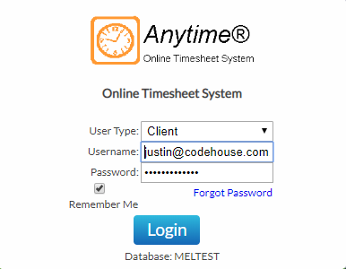Ensure the User Type is ‘Client’ and then enter your Username (email address) and password exactly as it appears in the welcome email and click **LOGIN**

*C:\Users\melissa\AppData\Local\Microsoft\Windows\Temporary Internet Files\Content.IE5\1L5TLMW8\MC900434824[1].png* ***Note:*** *When you log in for the first time, you will be required to enter a New Password*

*Forgotten Password*

If you have forgotten your password click **FORGOT PASSWORD**

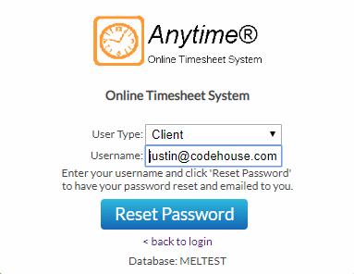In the Reset Password screen check the User Type is ‘Client’ and enter your Username

Click **RESET PASSWORD**

A temporary password will be emailed to you.

To return to the Login Screen click **BACK TO LOGIN**

# MAIN MENU

The Main Menu of the Client Screen consist of the following

* Timesheets
* Apply Leave
* Reports
* Placements
* My Profile
* Notifications

Each area can be accessed by clicking on the heading and then the relevant tab

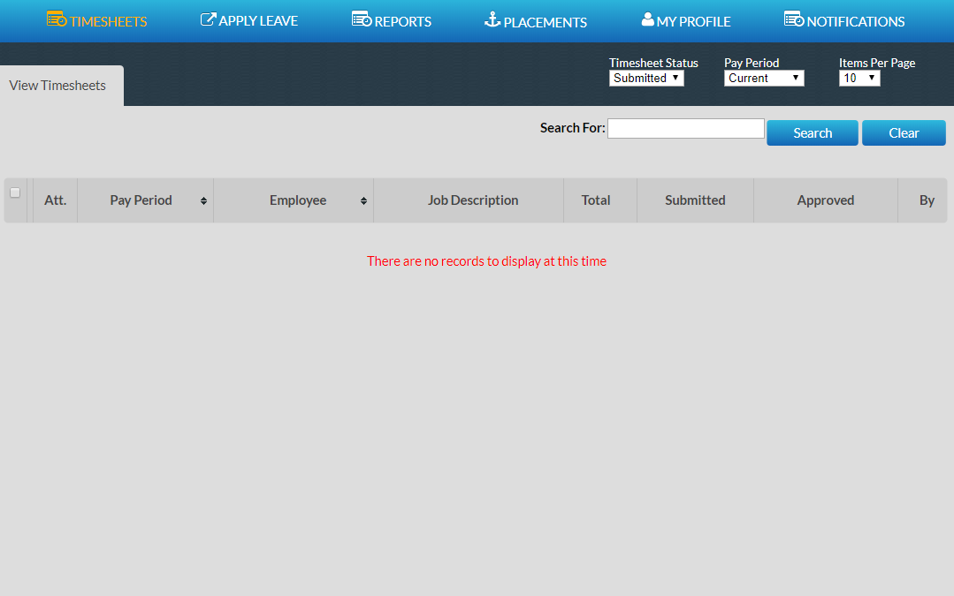

When viewing details in any screen you can select the number of records that display on the page by selecting the amount from the ‘Items Per Page’ field



To move between pages use the scroll arrows or page numbers at the bottom of the screen

You can also filter on details displayed in screens by entering the data in the ‘Filter For’ field and clicking **SEARCH**



## TIMESHEET

### VIEW TIMESHEETS

Here you can view timesheets filtered by a Timesheet Status and Pay Period.

Use the drop down menus to select the Timesheet Status and Pay Period.

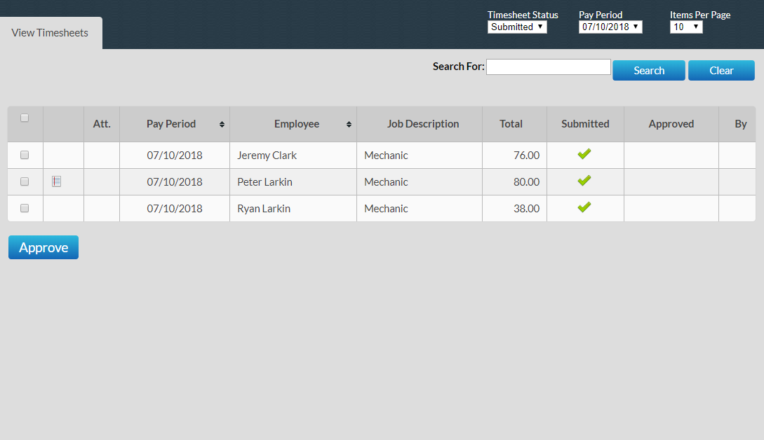

You can select to view timesheets based on the following status:

Submitted Timesheet has been submitted and awaiting approval

Approved Timesheet has been approved by Supervisor

All Display all timesheets

To view a timesheet click on the line of the Timesheet you wish to view

*C:\Users\melissa\AppData\Local\Microsoft\Windows\Temporary Internet Files\Content.IE5\1L5TLMW8\MC900434824[1].png****Note****: When accessing the system if you have been registered as a Line Manager you will be able to view all Timesheets and Placements.*

*If you have been registered as a Supervisor you will only be able to view Timesheet and Placements of Employees that have directly been assigned to you and your own User Account details.*

### EMAIL NOTIFICATION FOR SUBMITTED TIMESHEETS

When a timesheet has been submitted all Line Managers and the Supervisor assigned to the timesheet will receive an Email to notify them that the Employee has submitted a timesheet and you will need to log on and approve the timesheet

The Email will display a summary of the timesheet that has been entered and a breakdown of any allowances.

This section displays how the timesheet will be broken down into the various pay and charge rates that will appear on your invoices.

Sample Email:

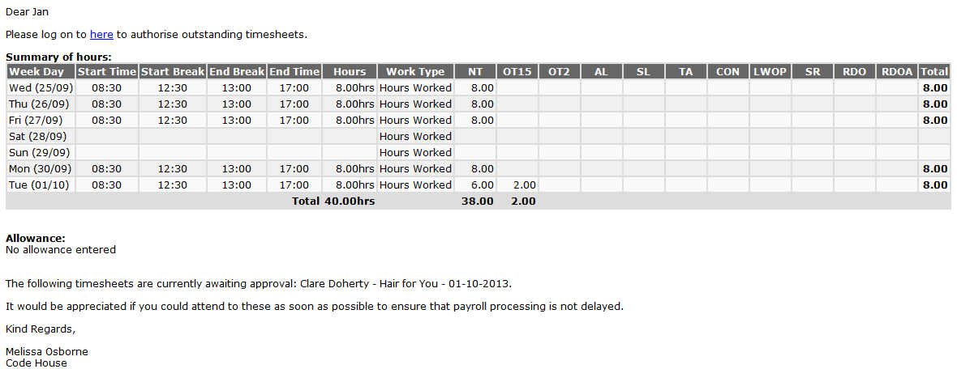

To open and approve the timesheet from the email click on **HERE**

This will take you to the log in screen where you can enter your, Username and Password.

*C:\Users\melissa\AppData\Local\Microsoft\Windows\Temporary Internet Files\Content.IE5\1L5TLMW8\MC900434824[1].png****Note****: If you have checked the ‘Remember Me’ checkbox then these details will already be entered and you will just need to click* ***LOGIN***

The timesheet is then approved in the same manner as below.

*C:\Users\melissa\AppData\Local\Microsoft\Windows\Temporary Internet Files\Content.IE5\1L5TLMW8\MC900434824[1].png****Note****: Where the option has been enabled notifications may also be received by SMS*

### APPROVING TIMESHEETS

Timesheets are approved or rejected via the View Timesheets screen

To view all unapproved timesheets select ‘Submitted’ from the Timesheet Status

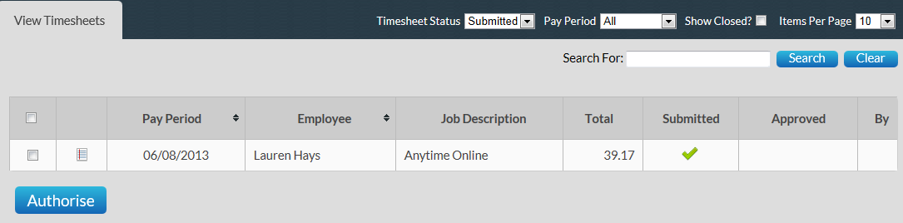

Click on the timesheet that you wish to view

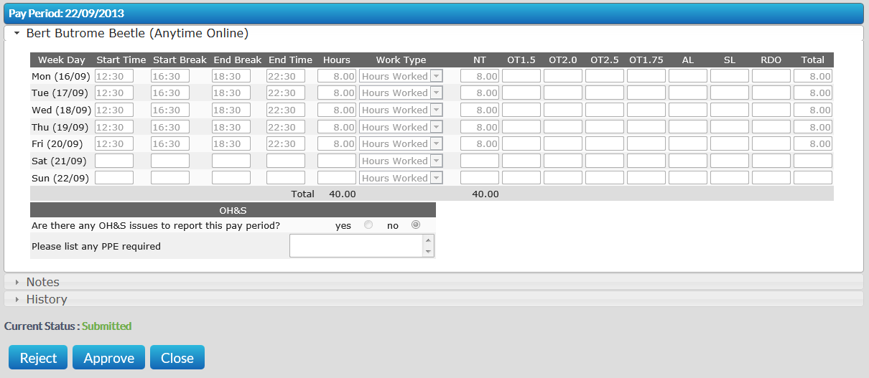

The timesheet is displayed as entered by the Employee and also includes a breakdown of the hours against Pay Items that determine the charge rates that will appear on your Company’s invoice for the timesheet.

To view a note entered against a Work Type click on the symbol

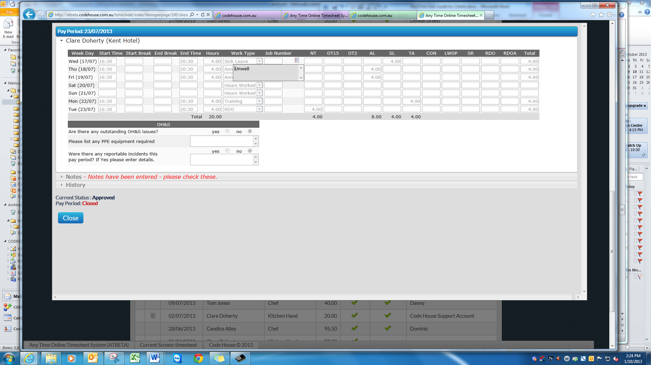

Where Allowances and Notes have been entered or documents have been attached they can be viewed by clicking on the to expand the drop down window

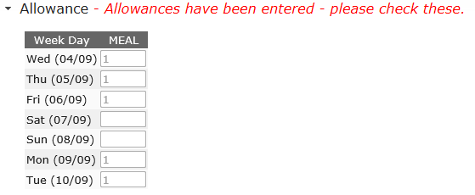

To approve the timesheet click **APPROVE**

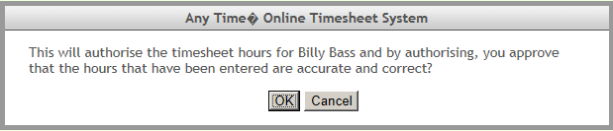

Confirm the timesheet is correct then click **OK**

This will return you to the View Timesheets screen and you can approve further Timesheets in the same manner

Once the Timesheet has been approved an email will be sent to The Employee, all Line Managers and the Supervisor indicating the timesheet has been approved.

#### Rejecting Timesheets

If the timesheet is incorrect and needs to be amended by the Employee click **REJECT**

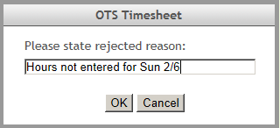

Enter a reason the timesheet has been rejected

Click **OK**

The employee will receive an Email (SMS) to advise their timesheet has been rejected and they need to resubmit it

**WHS Questions** (where applicable)

Some Employers may require Employees and hosts to answer basic WHS question when submitting your timesheet.

If you have the following screen is displayed on the timesheet, with questions in an orange box, you will not be able to approve the timesheet until all Yes/No questions have been answered.

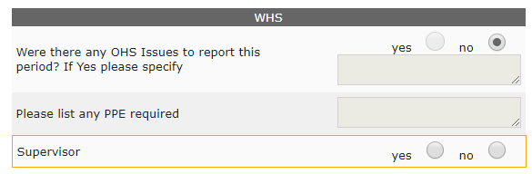

If you answer yes to any of the questions or enter data in any of the text fields this information will be automatically emailed through to the WHS contact for the Company.

### MULTI APPROVE TIMESHEETS

This function allows you to approve multiple timesheets at the same time.

To approve multiple timesheets go to View Timesheets and select ‘Submitted’ from the Timesheet Status drop down menu and the required Pay Period.

To view details of the timesheet without opening the timesheet hover your mouse over the employee’s name

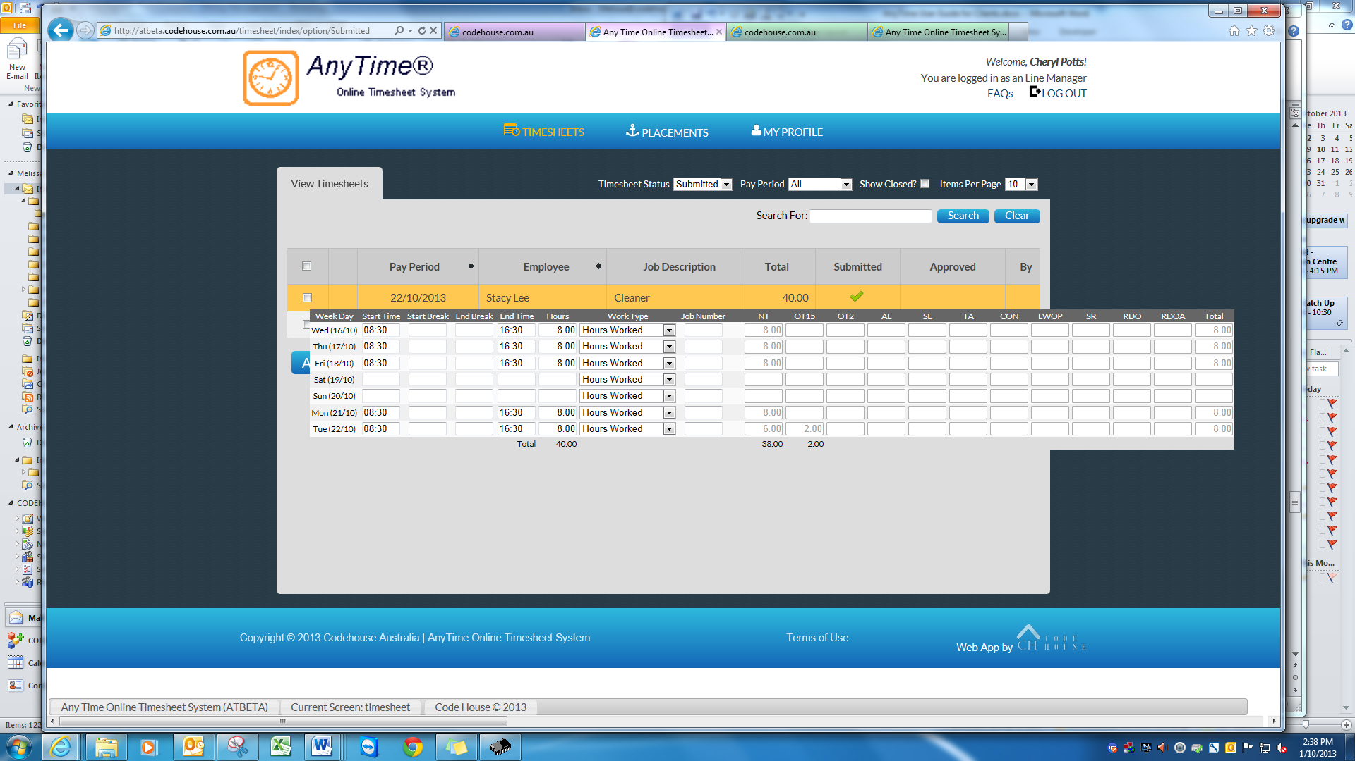

*C:\Users\melissa\AppData\Local\Microsoft\Windows\Temporary Internet Files\Content.IE5\1L5TLMW8\MC900434824[1].png*This will display the timesheet details at a glance without having to open the timesheet

***Note****: Any timesheets that have Notes or Allowances entered will be identified by the icon and it is recommended that these timesheets be viewed in full details by clicking on the timesheet line as outlined above*

Once previewed multiple timesheets can be approved by clicking on the checkbox in the first column

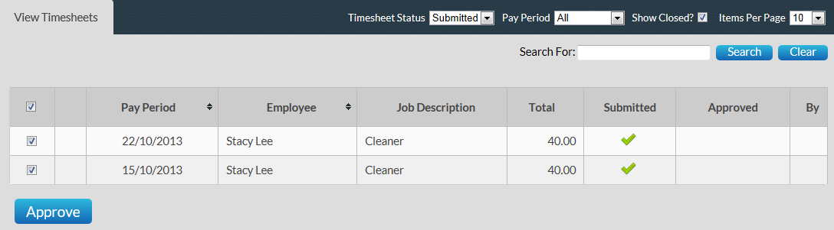

This will tick the checkbox against every timesheet on the page.

*C:\Users\melissa\AppData\Local\Microsoft\Windows\Temporary Internet Files\Content.IE5\1L5TLMW8\MC900434824[1].png****Note****: Remove the tick in the checkbox from any timesheet you do not wish to code and save at this time.*

To approve all timesheets ticked click **APPROVE**

An email will then be sent to all Line Managers and the Supervisor noting the timesheet(s) that have been approved

*C:\Users\melissa\AppData\Local\Microsoft\Windows\Temporary Internet Files\Content.IE5\1L5TLMW8\MC900434824[1].png****Note****: This feature is not available where there are questions that need to be answered prior to approving timesheets.*

### APPROVE TIMESHEETS ‘ON THE SPOT’

The system also includes functionality so that you can approve a Timesheet ‘on the spot’ via the Employee Timesheet entry screen.

This function is just like you being handed a manual timesheet from the Employee and you signing it immediately.

To access this function when the Employee has entered their timesheet they need to click **SUBMIT & APPROVE**

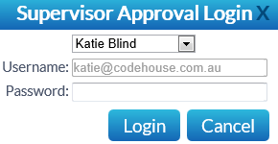

Where you are the supervisor assigned against the timesheet your Username will be automatically populated. Alternatively you can select your name from the Supervisor drop down menu

Enter your password and click **LOGIN**

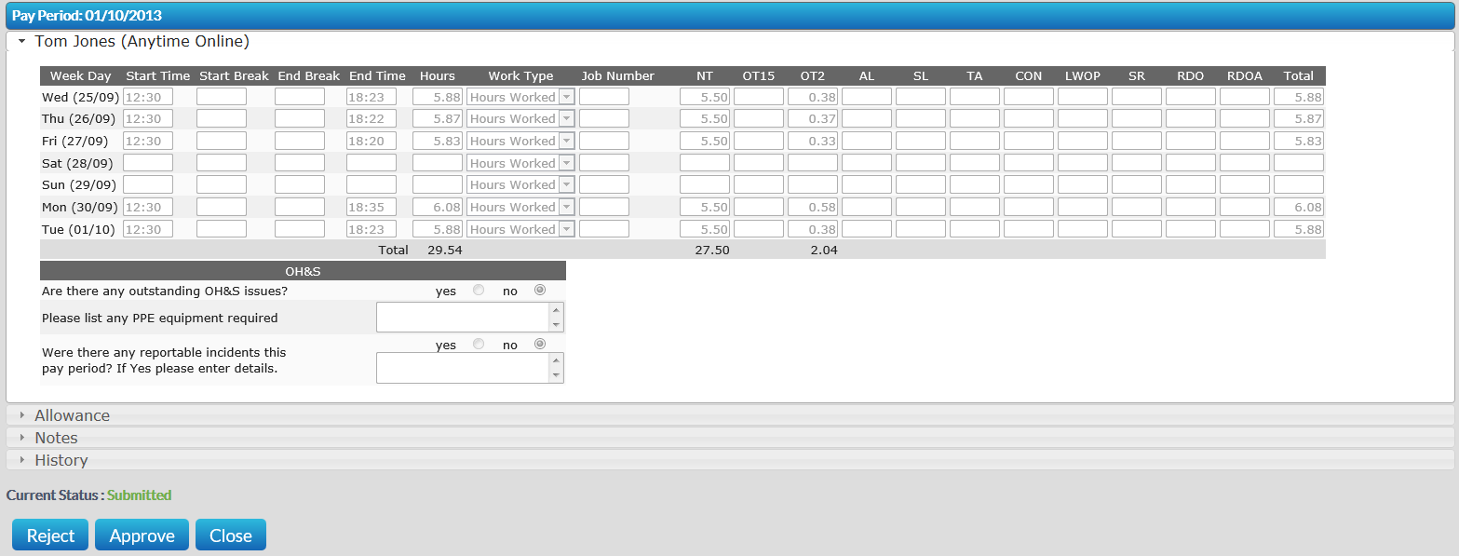

You can then Approve (Reject) the timesheet in the same manner as outlined above.

*C:\Users\melissa\AppData\Local\Microsoft\Windows\Temporary Internet Files\Content.IE5\1L5TLMW8\MC900434824[1].png* ***Note****: Once you have logged in and approved the Employee’s timesheet the system will automatically log you out and return the Employee to their profile*

## REPORTS

### REPORTS

This screen enables you to generate and print a report to display the Job Numbers/Sites employees have worked for a specified period

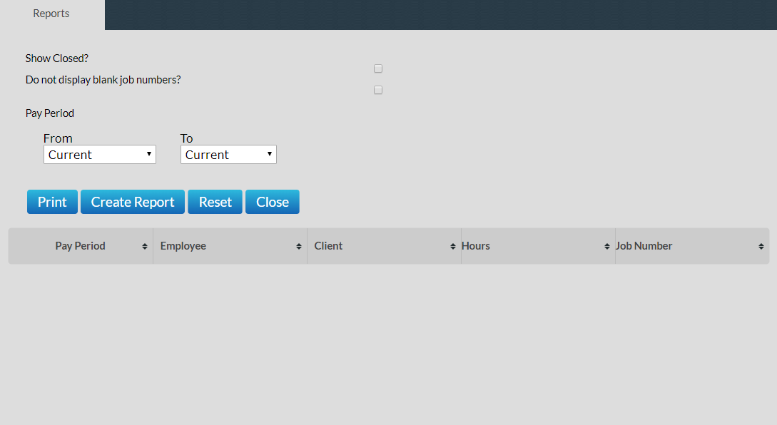

To generate the report select the pay period end date range to report on

To bring the report up to screen click **CREATE REPORT**

To print the report click **PRINT**

To close the report and return to the main report menu click **CLOSE**

## PLACEMENTS

The Placement tab provides you with summary details of all current active Placements for your Apprentices/Employees including

* Employee Name
* Client
* Start Date
* End Date
* Pay Cycle
* Job / Award Description
* Supervisor
* Purchase Order

Line Managers will be able to view details for all Employees

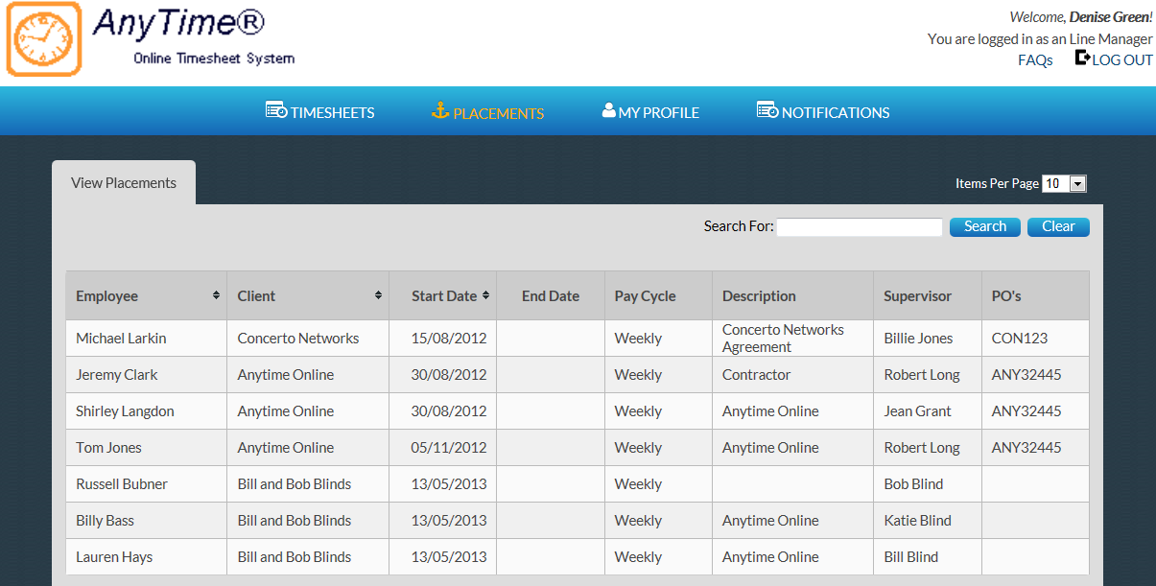

Supervisors will only be able to view details of Employees assigned to them

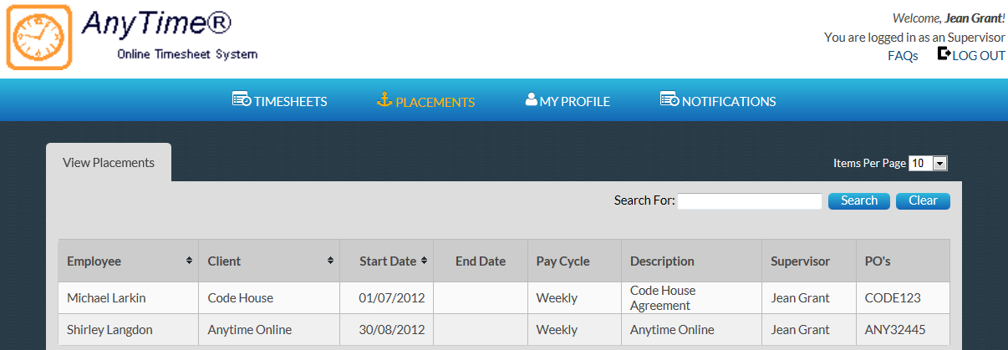

## MY PROFILE

This tab enables you to view your User details.

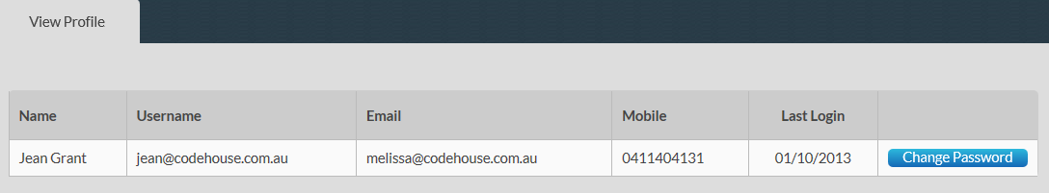

You can change your password in this screen by clicking **CHANGE PASSWORD**

Enter a new Password as you did when you logged into the system the first time.

For changes to email addresses and mobile numbers please contact your Supplier.

## NOTIFICATIONS

This screen displays any messages that have been previously viewed when opening the online timesheet system

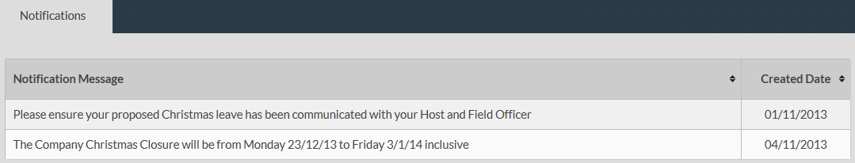

## FREQUENTLY ASKED QUESTIONS

To view the frequently asked questions click **FAQs**

Click on the question to view further information

## LOG OUT

To log out of the AnyTime Online Timesheet system click on **LOG OUT**